Farm2Door

Organic Produce Delivery Platform

Full Stack Web Development

BSCSev-V-B
PROJECT PROPOSAL

Group Members:
- Muhammad Abdur Rehman (232510)
- Faria Ahmed (232486)
- Abeera Zainab (232997)
Submitted on:
26th November,2025
Deliverable: System analysis & high-level architecture report

1. Executive summary
Farm2Door is a full‑stack web platform connecting customers with local organic farmers for ordering and home delivery of fresh produce. The system supports product browsing, ordering, payment, delivery tracking, inventory and supplier management, and reporting for business insights.

2. Core Functional Modules (6–8)
- User Management
- Product & Catalog Management
- Order & Checkout Management
- Inventory & Supplier Management
- Delivery & Logistics
- Payments & Billing
- Reporting & Analytics
- Notifications & Communication

2.1 Advanced & Optional Feature Modules

A. Smart Recommendation Engine
- Personalized product suggestions
- Seasonal recommendations
- Frequently bought together logic
- Location‑based recommendations
- Health‑based product suggestions

B. Subscription & Recurring Deliveries
- Weekly/Monthly produce boxes
- Auto-renew payments
- Custom subscription builder
- Pause/resume subscription

C. Farm Profiles & Storytelling
- Farm profile pages
- Farming method details
- Certifications & trust badges
- Farm gallery (photos/videos)
- Customer reviews for farmers

D. Dynamic Pricing System
- Seasonal pricing updates
- Bulk discounts
- Vendor‑specific discount rules
- Demand‑based pricing adjustments

E. Packaging Preferences Module
- Eco-friendly packaging options
- User notes (“No plastic please”)
- Special handling instructions

F. Advanced Delivery Management
- Route optimization (basic)
- Live order tracking
- Delivery time prediction (ETA)
- Delivery heatmap (admin)
- Delivery slot selection

G. Loyalty, Points & Rewards System
- Points earning system
- Redeem points for discounts
- Customer levels (Bronze/Silver/Gold)

H. Chat Support & Ticket System
- Live chat (basic)
- Chatbot for FAQs
- Complaint/issue ticketing

I. Smart Inventory System
- Low-stock alerts
- Auto-reorder suggestions
- Batch/harvest date tracking
- Expiry alerts

J. Sustainability Score Module
- Eco-score calculation
- Carbon footprint estimation
- Water usage indicators
- Local distance score

K. Recipe Suggestion Module
- Recipes based on purchase history
- Auto-add ingredients to cart
- Seasonal recipe suggestions

L. Vendor/Farmer Analytics Dashboard
- Revenue breakdown
- Best-selling products
- Seasonal demand analysis
- Inventory turnover metrics

M. Location-Based Shopping
- Show nearby farms first
- Local delivery discounts
- Freshness indicators (e.g., harvested hours ago)

N. Messaging System (Customer ↔ Farmer)
- Ask farmer questions
- Harvest updates from farmers

O. Farm Stories & Media
- Farmer photo albums
- Short video uploads
- Livestream events

P. Multi-language Support
- Urdu / English / Punjabi / Sindhi
- UTF-8 support throughout system

3. Sub‑modules (4–6 sub‑features each)

1. User Management
- Customer registration / login (email, phone, OAuth)
- Vendor/Farmer registration & onboarding
- Role & permission management (RBAC)
- Profile management (addresses, KYC for vendors)
- Password reset / 2FA / session management

2. Product & Catalog Management
- Product CRUD (create/update/delete)
- Category & subcategory management
- Product variants (weight, pack size), units & pricing
- Product images & media management
- Search & filters (organic, seasonal, price, vendor)
- Promotions & discounts (coupon, bundle)

3. Order & Checkout Management
- Cart management
- Checkout flow (address, delivery slot, payment)
- Order creation & status lifecycle (Placed → Confirmed → Packed → Out for delivery → Delivered → Returned)
- Order history & invoices
- Refunds & cancellations
- Subscription / recurring orders (weekly veg box)

4. Inventory & Supplier Management
- Vendor inventory stock levels & low-stock alerts
- Batch & lot tracking (harvest date, expiry)
- Purchase orders (platform → vendor) and restocking
- Supplier profiles & rating
- SKU mapping & warehouse locations (if multiple)

5. Delivery & Logistics
- Delivery slot scheduling
- Route assignment & optimization (basic)
- Rider apps / dashboard (accept jobs, update status)
- Real-time tracking (ETA) and proof-of-delivery
- Returns & failed-delivery handling

6. Payments & Billing
- Multiple payment gateways integration (cards, mobile wallets)
- Payment status reconciliation
- Wallet / store credit system
- Invoicing & receipts (PDF)
- Commissions & payouts to vendors

7. Reporting & Analytics
- Sales dashboard (revenue, orders, AOV)
- Vendor performance & product analytics
- Inventory reports (stock outs, turnover)
- Customer analytics (LTV, repeat rate)
- Exportable reports (CSV / Excel)

8. Notifications & Communication
- Email templates & transactional emails
- SMS & push notifications (order updates, OTP)
- In-app messaging between customer & rider/vendor
- Notification preferences & logging

4. User Roles
- Admin (Super Admin) — full platform control (users, payments, reports)
- Customer — browse, order, review, manage subscriptions
- Vendor / Farmer — manage products, inventory, receive orders, view payouts
- Delivery Rider — receive deliveries, update order status, GPS tracking
- Operations / Support Staff — manage exceptions, refunds, customer support
- Finance / Payout Admin — reconcile payments, trigger vendor payouts

5. Key Entities / Database Tables
For each table, key columns and brief notes on relationships.
- users
- id (PK)
- name
- email
- phone
- password
- hash
- role
- address_json
- is_active
- created_at
- updated_at
- vendors
- id (PK)
- user_id (FK→users)
- farm_name
- location (geo)
- kyc_status
- rating
- payout_info
- products
- id (PK)
- vendor_id (FK→vendors)
- title
- description
- category_id
- sku
- unit
- price
- cost_price
- image_urls
- available_from
- available_to
- is_active
- categories
- id (PK)
- name
- parent_id (nullable)
- slug
- product_variants
- id (PK)
- product_id (FK→products)
- variant_name (e.g., 1 kg, 500 g)
- price
- stock_qty
- batch_info
- carts
- id (PK)
- user_id (FK→users)
- created_at
- cart_items
- id
- cart_id (FK→carts)
- product_variant_id (FK)
- qty
- price_at_add
- orders
- id (PK)
- user_id (FK→users)
- vendor_id
- total_amount
- discount
- tax
- delivery_fee
- status
- payment_id (FK→payments)
- delivery_slot
- created_at
- order_items
- id
- order_id (FK→orders)
- product_variant_id (FK)
- qty
- unit_price
- subtotal
- payments
- id
- order_id (FK)
- amount
- method
- gateway_txn_id
- status
- paid_at
- deliveries
- id
- order_id (FK→orders)
- rider_id (FK→users)
- status
- assigned_at
- picked_at
- delivered_at
- gps_path
- inventory_movements
- id
- product_variant_id (FK)
- change_qty
- reason (sale/adjust/receive)
- timestamp
- reviews
- id
- user_id
- product_id
- rating
- comment
- created_at
- notifications
- id
- user_id (nullable)
- channel (email/sms/inapp)
- template
- payload_json
- status
- sent_at
- payouts
- id
- vendor_id
- amount
- period_start
- period_end
- status
- processed_at
- subscriptions
- id
- user_id
- plan_id
- next_charge_date
- status
(Indexes: on fk columns, product search fields, order created_at)

6. High‑Level Architecture
[Customer Browser / Mobile App] <---> [Web/API Gateway] <---> [Backend Services]
| |-- Auth & User Service
| |-- Product Service
| |-- Order Service
| |-- Inventory Service
| |-- Payment Service
| |-- Notification Service
|
v
[Database Cluster]
|
v
[External Integrations]
- Payment Gateway (e.g., Stripe/PayPal)
- SMS Gateway
- Maps / Routing API
- CDN for images
Admin Dashboard <----> Backend Services
Vendor Portal / Rider App <----> Backend Services
Notes: - API Gateway or BFF (Backend-for-Frontend) serves mobile/web clients - Services may be implemented as modular REST endpoints or microservices depending on course scope - Use a relational DB (Postgres) for transactions; optional Redis for carts & caching
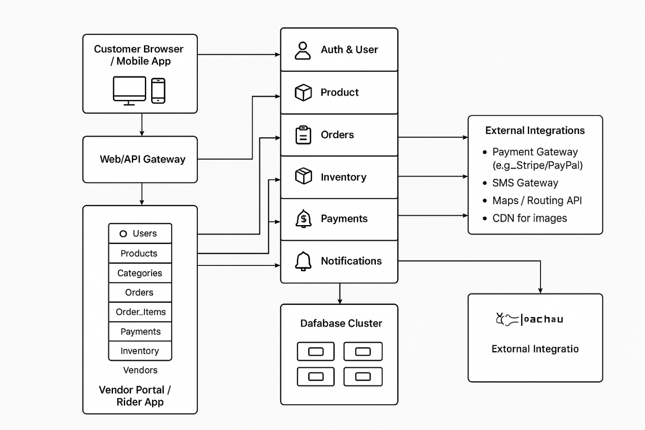

7. System Workflow
- Customer registers / logs in and sets delivery address and preferences.
- Customer browses catalog (searches, filters) and adds product variants to cart.
- At checkout customer selects delivery slot, applies coupon, and pays via integrated gateway.
- Order Service creates order and reduces inventory (transactional). Vendor receives an order notification.
- Platform assigns a rider (manual or automated), rider updates status through Rider App; notifications sent to customer.
- Payment Service reconciles gateway response; upon successful delivery platform generates invoice and triggers vendor payout cycle.
- Admin/Analytics dashboards aggregate sales, inventory and vendor metrics for operations and finance.

8. Non‑Functional Considerations
- Security: JWT/OAuth2, HTTPS, input validation, RBAC, secure storage of secrets
- Scalability: Use caching for catalog, horizontally scale stateless services, separate read replicas for analytics
- Reliability: Background jobs for retries, idempotent operations for payments/orders
- Performance: CDN for images, Redis for session/cart cache
- Compliance: PCI‑DSS considerations for payments; data privacy for user data

9. Suggested Tech Stack (example)
- Frontend: React (or Next.js) + Tailwind
- Backend: Node.js (Express/NestJS)
- DB: PostgreSQL + Redis
- Payments: Stripe / PayPal / Local wallet
- Hosting: Docker → AWS/GCP/Azure (ECS/EKS or App Engine)

